Accommodation

Our Belgian hosts recommend booking a room in hotel Serwir. This hotel is located within walking distance (approx. 20 min. / 1,6 km) from the Walburg Castle.
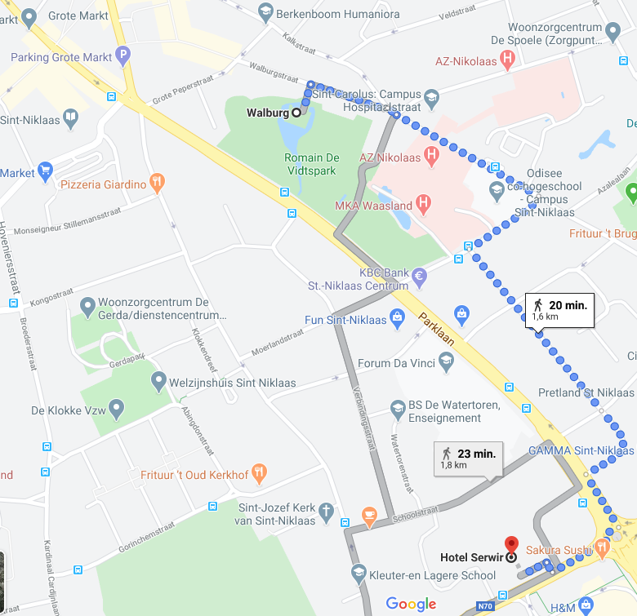
Hotel Serwir ****

Reservation
If you wish to make a reservation at Hotel Serwir, please send an email to info@serwir.be and refer to: ‘VVSG – groupbooking’. If you do this before May 15th, your stay will be garanteed and you can enjoy our groupdiscount. (€105 per night, breakfast included)
Please note: we have come to understand that the hotel will be closed until the 3rd of April, in view of the COVID 19 outbreak. This might mean that you will not be able to make reservations before the 3rd of April.

Other available hotels are:
- Hotel New Flanders***
- Hotel Moon***
- Hotel de Spiegel*

Meeting venue and rooms
Kasteel Walburg
Walburg 35
9100 Sint-Niklaas
http://walburg.be/nl/contact/

Visa requirements for Belgium
If you are visiting Belgium and are a citizen of a non-EU country, you may need a visa. Please check https://diplomatie.belgium.be/en/services/travel_to_belgium/visa_for_belgium.

Travel from airport (BRU) to Sint-Niklaas

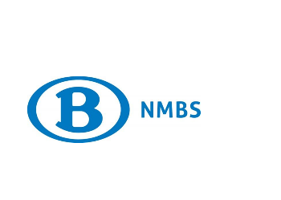 | There are multiple trains per hour going from Brussels Airport Zaventem to Sint-Niklaas station (€13 one way, €26 return). You can buy a ticket online, or at the station.  The journey time is approximately 47 to 52 minutes. You will have to make a stop-over at Antwerpen-Berchem station. The train runs every 30 minutes from 6.11 a.m. to 10.41 p.m.  For accurate times, check the NMBS Website.
From/to the airport to/from any place in Sint-Niklaas by taxi
From the airport to Sint-Niklaas: Airport taxis – book online or call +32 466 903 999
Price: app. €58 price depends on the kind of car
Duration: 45 minutes
From Sint-Niklaas to the airport and in Sint-Niklaas:
Taxi Waas – book online or call +32 470 440 534
Price to drive to the airport: €56
You can best arrange your taxi through your hotel.

Contact details

Should you have any questions, please feel free to contact the CIB Working Group secretariat at uclg.cib@vng.nl, +31 70 3737 8707.

During the meetings:
Jessie Post (CIB secretariat) + 31 6 12156647
Stan Abma (CIB secretariat) + 31 6 83140750

Contact details VVSG
Hanne Albers +32 498 20 32 14

Information about Belgium/Sint-Niklaas

Time zone
CET (Central European Time) UTC/GMT + 1

Voltage/electricity
230 V (50Hz) and the power plugs and sockets are type C and E. This socket also works with plug F.

Business hours in Belgium
Monday till Friday 08:00/09:00 am – 06:00/07:00 pm
Saturday 08:00/09:00 am – 06:00 pm
Sunday: Several shops in the Brussel will be open.
All the shops in Sint-Niklaas close on Sundays, except for a few supermarkets

Banks and currency
Belgium belongs to the euro currency zone / Euro (EUR)
Most hotels and businesses accept Mastercard, Visa and Maestro. Only a few accept American Express.

Banks usually are opened on
Monday, Tuesday, Wednesday and Friday 08:30 am – 00:30 pm and 14.00 pm – 17.00 pm
Thursday 08:30 am – 00:30 pm and 14.00 pm – 06.00 pm

Telephone country code & area code
+ 32 (Belgium)
9200 – Sint-Niklaas

Emergency phone numbers
112 – European emergency number
112 – Fire brigade
101 – Police
112 – Ambulance service

