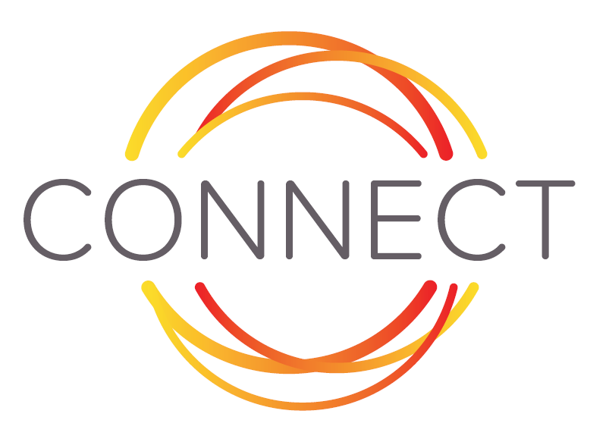

« A mechanism to provide a quick and adequate response to worldwide requests for capacity development and learning in which European local and regional governments expertise is involved. »

Application form
Local or regional governments of European Union Partner Countries

CONNECT is a mechanism developed by PLATFORMA and VNG International. The mechanism facilitates short-term, demand-driven knowledge transfers between local and regional governments in EU partner countries and local and regional governments in Europe. The CONNECT mechanism works complementary to other existing forms of cooperation between municipalities.

CONNECT brings supply and demand together and acts as a catalyst for change. One of the mechanism’s main strenghts is its colleague-to-colleague appoach: by bringing colleagues from different municipalities together, a sphere of trust and understanding is created instantly, deriving great results.

Within the pilot of CONNECT (which took place in Spring 2016), the mechanism was tested in Ghana, Cambodia and Colombia and topics of exchange included Human Resources Management and Sanitation. The pilot showed that the short term interventions did indeed lead to change at the individual and organisational level. The former participants confirm that it might also lead to follow-up partnerships or activities.

The CONNECT mechanism is financed under the Strategic Partnership Agreement between PLATFORMA and the European Commission. Additional exchanges can be facilitated by the CONNECT team on demand of national governments or the international donor community.

For more information about the mechanism, please watch the video about the CONNECT mechanism here and read the flyer here. You can also always contact the CONNECT team by sending an email to connect@ccre-cemr.org.

CONNECT
Sharing local and regional governments’ expertise worldwide
Application form
This application form is to be filled out by local or regional governments in countries outside of Europe requesting expertise from their European counterparts in the context of the CONNECT initiative, in the form of a group exposure visit. Based on the formulated demand, a European partner (and, where relevant, Southern partner) will be sought to help you tackle your challenge.
What is a group exposure visit?

A group exposure visit takes place when the challenge addressed concerns a number of local or regional governments in an EU partner country and exposure to practices and systems abroad can help tackling the identified challenge/s back home. Consequently, a group exposure visit takes place in a European country, or in another Southern country if more relevant. The duration of the group exposure visit depends on the request.

The goals and expected results of the group exposure visit are captured in Terms of Reference, put in writing by all local or regional governments that were selected and matched to each other, as a joint effort. Given the involvement of multiple local governments in the request, the involvement of the local government association is required.

This application form consist of three parts:
- Contact information
- Some factual details about your municipality
- Description of the content of the knowledge exchange

Please note that the request will only be considered if:
- The applicants are local or regional governments in an EU partner country
- It includes letters of commitment from each of the municipalities, signed by a political office bearer, showing the motivation of the municipality and the specification of which logistics can be ensured by the municipality (please find a format for the letter of commitment attached)
- One municipality acts as lead applicant and is the main point of contact for the CONNECT team
- A contact person that can act as focal point has been identified within each municipality
- This application format is used and all sections are completed.
- The application is submitted electronically, by sending an email to the address below. Please also share a copy with your national association of local/regional governments.

The CONNECT team will select the most relevant and complete demand for assistance and share this demand with European local and regional governments. The possibility of establishing a connection is dependent on the availability of expertise, and can therefore not be guaranteed.
Please send this application form to:
PLATFORMA,
To the attention of CONNECT
Email address: connect@ccre-cemr.org

What will happen with your application form?

- After receiving your application the CONNECT team will be in touch with the lead applicant (see below) to fine-tune the statements in the application. Points for clarification will be addressed.

- The CONNECT team will share all applications with the CONNECT selection committee which will select the best application for this round of CONNECT.

- In case your application is selected, the lead applicant will be informed directly by the CONNECT team. After receiving confirmation from you that your local or regional government is still interested to participate, we will share your request for assistance with our network or European local and regional governments.

- After receiving reactions from the European local and regional government, the CONNECT selection committee will review them and select the most suitable government for this job. Both the European local/regional government and your government will be informed about the CONNECTion soon after.

- When the CONNECTion has been made, all parties involved will work on a programme and Terms of Reference for the roundtable expert meeting. These documents will also contain the exact dates and duration of the meeting and the reporting requirements.

CONNECT: time investment

The time investment when taking part in CONNECT is the following:

Before the match/selection

Drafting the application | 1 day
Revision and finalization (in consultation with national association of local/regional governments) (all municipalities) | 0,5 days
Skype meeting with CONNECT team to fine-tune the application before selection is made (lead applicant only) | 2 hours

After the match/selection

2 preparatory skype meetings with the European municipality – filling out of planning document (template of CONNECT) | 2 hours each
Elaboration and finalization of the Activity program (for the mission) in contact with the European municipality (lead applicant only, in consultation with others) | 2-5 hours
Preparing for the mission: preparing discussions and documentation, arranging logistics etc. | 1 day

After the knowledge exchange

Work on finalization of the joint report and deliverables of the mission (to be send to the receiving (EU) municipality and CONNECT team) (lead applicant takes the lead) | 0.5-1 day
Completion of the change observation forms and satisfaction survey (all municipalities) | 0.5-1 day

Altogether, the time investment equals 4,5 days for preparation and reporting. The knowledge exchange itself will last between 5 and 10 work days, depending on the request of the municipalities. Up to 2 days are necessary for monitoring, evaluation and reporting. For the preparation and reporting, the lead applicant plays a bigger role than the other municipalities.

- Contact information

Details of lead applicant (on behalf of up to 9 municipalities):
Name of local or regional government
Address (city, country)
Name of applicant
Position of applicant
Phone number
E-mail address

Details of focal point in each municipality:
A focal point is important to prepare the exchange and needs to ensure efficient contact. Please take into consideration that the focal point needs to answer to a number of criteria:
- He or she needs to be on the pay-roll of the municipality
- He or she needs to be able to communicate in English
- He or she needs to have sufficient authority in order to prepare and organise the exchange on behalf of their municipality
- He or she needs some days for preparation/reporting and for attending to (if applicable) the exchange. Please note: there is no reimbursement or fee for any of the participants in the exchange.

Municipality 1
Name of municipality
Name of focal point
Position of focal point
Phone number
E-mail address

Municipality 2
Name of municipality
Name of focal point
Position of focal point
Phone number
E-mail address

Municipality 3
Name of municipality
Name of focal point
Position of focal point
Phone number
E-mail address

Municipality 4
Name of municipality
Name of focal point
Position of focal point
Phone number
E-mail address

Municipality 5
Name of municipality
Name of focal point
Position of focal point
Phone number
E-mail address

Municipality 6
Name of municipality
Name of focal point
Position of focal point
Phone number
E-mail address

Municipality 7
Name of municipality
Name of focal point
Position of focal point
Phone number
E-mail address

Municipality 8
Name of municipality
Name of focal point
Position of focal point
Phone number
E-mail address

Municipality 9
Name of municipality
Name of focal point
Position of focal point
Phone number
E-mail address

- Some factual details about local governments in your country
Basic information on the Local Governments in your country | Amount of inhabitants, number of employees etc.
Vision of the applying municipalities on international collaboration
Basic information on the policy field chosen | What is the exact function of the government/municipality/community in this policy field?
Reason for requesting the exchange

Additional documents added:
Such as:
- Description/scheme of organisational structures of municipalities
- Documents describing the policies related to the policy field
- Information about the issue or problem

Details of current contacts with European local or regional governments (if applicable):
Please note: the local or regional government with whom your association is already working, can apply to assist you in this specific challenge, if they want to. However, CONNECT will always invite other local and regional governments to propose an offer and the selection will be done by CONNECT based on the best offer.
Name of local or regional government
Name of local or regional government (European Union)
Country
Name of contact person
Type of interaction
Phone number
E-mail address

Name of local or regional government
Name of local or regional government (European Union)
Country
Name of contact person
Type of interaction
Phone number
E-mail address

- Description of the content of the knowledge exchange (max 1 page)
- Describe the problem or issue you would like to address during the exchange

- Why is it important for the applying municipalities to address this issue now?

- What has been done already by the municipalities to deal with the issue or the problem ? (specify per applying municipality)

- Is there currently any initiative at the national level or in a donor programme that addresses the same issue ? Please contact your national association of local/regional governments for more information on this.

- What is the change to which the exchange should contribute?

- Describe what you would expect and like to see different as a result of the knowledge exchange?

- What kind of assistance do you expect from the European municipality?

- Which department(s) within your local or regional governments will be involved in the exchange? (specify per applying municipality)

Countries where the EU development policies and instruments are applicable.

